**Applicant Help Centre Content**

| **Note**: This document is for writing & editing content that will be published on the help centre. For implementation-related information, refer to the [Applicant help center requirements](https://docs.google.com/document/d/1sJGKOZ8Vzg0FsO-6SQHaAVyHM0gyKcQ7sKqyQJAI2js/edit#) doc. |
| --- |

**The structure of this doc mirrors how the content will be displayed on the actual help centre.** Folders (indicated by 📁) can contains one or more files (indicated by 📄). Use the “document outline” on the left to easily navigate the doc.

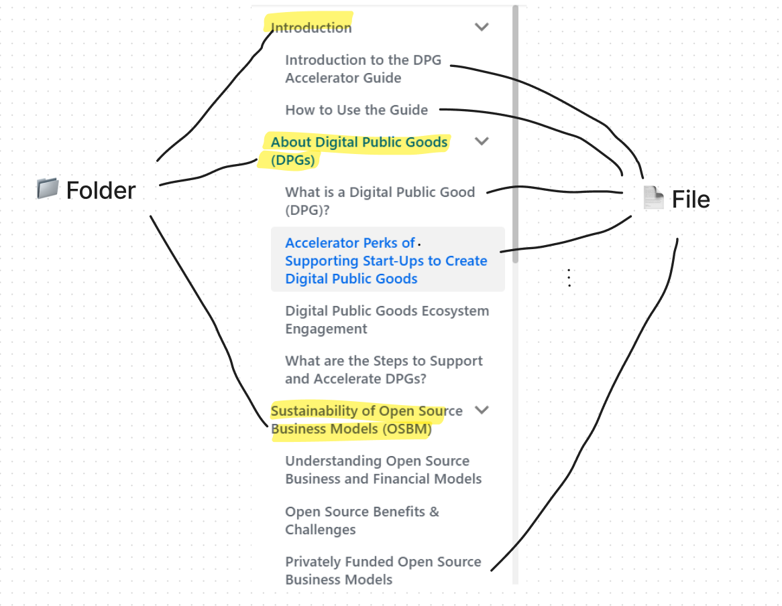

**Resources**

Links to existing help docs that are spread across the website and GitHub. These must be absorbed into the help centre and then deleted / modified to avoid confusion at the time of change propagation.

* <https://github.com/DPGAlliance/publicgoods-candidates/blob/main/docs/overview.md>
* <https://unicef.github.io/publicgoods-accelerator-guide/becoming-digital-public-good/nomination>
* FAQs in <https://digitalpublicgoods.net/eligibility/>
* <https://digitalpublicgoods.net/submission-guide/>
* <https://resources.digitalpublicgoods.net/>
* Nathan’s email.
* [Indicatorwise hints](https://docs.google.com/document/d/15l7g_CVzagZK72fb0g1Ptafyzm5DJbqqkYZi3eWDjqg/edit)

# 📁Home

### 📄Intro

Addresses a new applicant and gives them a quick overview, include the video here.

### 📄Review Process

### **📄FAQs**

**Q. My application was rejected.**

This could be because of the 3 reasons: failing any of the first three indicators, failing to respond to clarification on time, failing any of the last six indicators.

# 📁Application

### 📄Project Info

**Requirement**

**Open Software**

**Open Data**

**Open Content**

**Open Standard**

**Open AI Model**

**Sample project description**

### 📄SDG Relevance

**Requirement**

**What is an SDG?**

**List of all 17 SDGs**

**What exactly does being “relevant” mean?**

**How to demonstrate relevance to an SDG?**

Add 3-4 sample responses.

### 📄Open Licensing

**Requirement**

**List of approved open licences**

<https://github.com/DPGAlliance/publicgoods-candidates/blob/main/docs/licenses.md>

**How to choose an open licences**

### 📄Clear Ownership

**Requirement**

**List of documents that can help prove ownership of the project**

**Sample responses**

### 📄Platform Independence

**Requirement**

**What is platform independence?**

**Examples of mandatory vs non-mandatory dependencies**

**How to demonstrate independence from a non-mandatory dependencies**

**Sample responses**

### 📄Documentation

**Requirement**

**List of required documentation**

**Examples of well-documented projects**

<https://github.com/DPGAlliance/publicgoods-candidates/blob/main/docs/help-center/documentation.md>

**Sample responses**

### 📄Data Extraction

**Requirement**

**What is non-PII vs PII data**

For the purposes of this document, personal data means data, in any form or medium, relating to an identified or identifiable individual who can be identified, directly or indirectly, by means reasonably likely to be used, including where an individual can be identified by linking the data to other information reasonably available. Personal data is defined by many regional and national instruments and can also be referenced as personal information or personally identifiable information.

**What is non-proprietary format**

**Examples of data extraction mechanisms**

**Sample responses**

### 📄Adherence to Privacy and Applicable Laws (Legal Compliance)

**Requirement**

**?**

### 📄Adherence to Standards & Best Practices (Standard Compliance)

**Requirement**

<https://github.com/DPGAlliance/publicgoods-candidates/blob/main/docs/help-center/best-practices.md>

<https://github.com/DPGAlliance/publicgoods-candidates/blob/main/docs/help-center/open-standards.md>

**?**

### 📄Do No Harm Design (1/3): Data Privacy & Security

**Requirement**

**Types of data that is considered as PII**

**Sample response to Data Privacy & Security**

<https://github.com/DPGAlliance/publicgoods-candidates/blob/main/docs/help-center/privacy.md>

### 📄Do No Harm Design (2/3): Inappropriate & Illegal Content

**Requirement**

**Examples of types of content**

**Sample response to Inappropriate & Illegal Content**

### 📄Do No Harm Design (3/3): Protection from Harassment

**Requirement**

**Sample response to Protection from Harassment**

# 📁Policies

### 📄Application Review Policies

Refer [Application review policies (public-facing)](https://docs.google.com/document/d/1IIFyZTWyGMZStg2fCaQWS3vgQQ3H5mZX0BkT_TMF8zE/edit) and adapt the policies.

**Decision**

All accepted applications are approved based on interpretation of information submitted by the applicant. All decisions can be subject to further evaluation. DPGA can revoke its decision based on subsequent reviews. Applicants will be given a chance to respond before the status of their application is updated.

**Validity Period**

All DPGs are valid for one year from the date of decision. Projects must refresh their status as a DPG by submitting a refresher application. Projects that do not refresh their status are deemed expired and removed from the DPG Registry.

**Escalation / Dispute Resolution**

If you do not agree with the decision, you can escalate the decision by following steps.